Disease Prediction from Clinical Symptoms
Data Preparation, Model Selection and Evaluation

1. Introduction
This report describes how the disease-prediction model was built and evaluated: cleaning the data, separating training and test records with an 80/20 split, selecting the most informative symptoms, and comparing the four best classifiers.

2. Implementation Environment
This work was carried out on Google Colaboratory (Colab), a free, cloud-based Jupyter notebook environment provided by Google. Colab was chosen for the following reasons:
- No local installation required: the Python data-science libraries the code imports (pandas, numpy, matplotlib, seaborn, scikit-learn) are pre-installed and immediately available.
- Free CPU compute: the preprocessing steps covered in this report (loading, cleaning, encoding, splitting and training the four classifiers on 243 records) require no GPU.
- Easy dataset import: the four CSV files were uploaded directly to the Colab session folder /content/DiseaseDataset/ and loaded with pandas.read_csv().
- Reproducible environment: all library versions are fixed by Colab runtime, and a fixed random_state (42) is used throughout, so any collaborator or reviewer obtains identical results.
- Interactive visualization: matplotlib figures render inline within the notebook, enabling immediate inspection of each plot.

2.1 Libraries and Tools Used in the Notebook
Table 2.1 lists the libraries imported in Section 1 of the code and where each one is used. Every imported function or class is called somewhere in the code.
Table 2.1: Libraries and functions used in the notebook (§ = notebook section).
Library / module | Functions or classes used | Purpose in the notebook
pandas (pd) | read_csv, str.strip, str.replace, concat, drop_duplicates, groupby, value_counts, DataFrame | Load the four CSV files, clean names, remove duplicates, build result tables (2–4, 9–11)
numpy (np) | arange, isin, flatnonzero, unique, mean, std, argsort | Indices and masks, Jaccard check, averages over repeated splits (7–12)
matplotlib.pyplot (plt) | hist, barh, plot, boxplot | All figures (5, 8, 10)
seaborn (sns) | set_style, heatmap | Figure style; confusion-matrix heat maps (10.1)
functools, time | partial, time.time | Fix the arguments of mutual_info_classif for SelectKBest; measure training and prediction time
sklearn.preprocessing | MultiLabelBinarizer, LabelEncoder, label_binarize | Multi-hot encoding of symptoms, integer disease labels (6); one-vs-rest labels for ROC-AUC (10)
sklearn.model_selection | train_test_split, StratifiedKFold, cross_val_score, GridSearchCV | Stratified 80/20 split (7); 3-fold stratified CV, choice of the number of symptoms (8.1), hyperparameter tuning (9)
sklearn.feature_selection | SelectKBest, mutual_info_classif | Keep the 30 symptoms with the highest Mutual Information (8)
sklearn.pipeline, sklearn.base | Pipeline, clone | Chain feature selection and classifier so that selection is repeated inside every CV fold; untrained copies for the repeated splits (10.2)
sklearn classifiers | LogisticRegression, SVC, MLPClassifier, RandomForestClassifier | The four models (9)
sklearn.metrics | accuracy_score, precision_recall_fscore_support, f1_score, confusion_matrix, matthews_corrcoef, cohen_kappa_score, roc_auc_score | Evaluation metrics (10)

3. Dataset Description
The dataset used in this project is the “Disease Symptom Prediction” dataset published on Kaggle. It is composed of four related CSV files rather than a single table and supports a multi-class classification task: predicting one of 41 possible diseases from a variable-length list of reported symptoms. Its main characteristics are summarised in Table 3.1.
Table 3.1: Summary of dataset characteristics.
Property | Value
Total records (dataset.csv) | 4,920 patient cases
Total columns (dataset.csv) | 18 (1 Disease label + 17 Symptom_1 ... Symptom_17 columns)
Target variable | Disease — 41 distinct classes
Distinct symptoms across all columns | 131 unique symptom names (confirmed both before and after text cleaning)
Class balance | Perfectly balanced — exactly 120 records per disease in the raw file; after duplicate removal 5–10 unique records per disease (Section 4.3)
Symptom-severity.csv | 133 rows — a severity weight (1–7) per symptom
symptom_Description.csv | 41 rows — one clinical description per disease
symptom_precaution.csv | 41 rows — up to 4 recommended precautions per disease

3.1 Role of Each File
Table 3.2 describes the role of each of the four files and the key columns used in the code.
Table 3.2: Role of each file.
File | Role | Key column(s)
dataset.csv | Main training file: one row per patient case, up to 17 reported symptoms plus the disease label | Disease, Symptom_1..17
Symptom-severity.csv | Assigns a clinical severity weight (1 = mild, 7 = most severe) to each symptom | Symptom, weight
symptom_Description.csv | Natural-language medical description for each of the 41 diseases | Disease, Description
symptom_precaution.csv | Up to 4 recommended precautionary actions per disease | Disease, Precaution_1..4

3.2 Initial Exploration
Before any cleaning, the raw dataset.csv file was inspected directly: 4,920 patient records, 41 distinct diseases, 17 symptom columns, and 131 unique symptom values across those columns. About 98% of the raw symptom values carry a leading space (for example " skin_rash" instead of "skin_rash"), and two disease names carry a trailing space ("Diabetes ", "Hypertension "). After the cleaning step described in Section 4.3 the count remained 131, which shows that each symptom was written with the same extra space everywhere; cleaning removed the spaces without merging or losing any symptom.
The same exploration from the code also showed that 4,616 of the 4,920 rows are exact copies of other rows. This is the most important data-quality problem of the dataset and is handled in Section 4.3 (Step 5).

3.3 Diseases Addressed in the Code
The 41 disease labels predicted by the model are listed in Table 3.3, together with the clinical description stored for each in symptom_Description.csv. The names are written exactly as they appear in the Disease column of dataset.csv, and they are ordered by the integer label that LabelEncoder assigns to them in Section 6.3 (labels 0–40).
Table 3.3: The 41 diseases in the dataset, their encoded label, and their clinical description.
Label | Disease (as in dataset.csv) | Clinical description (from symptom_Description.csv)
0 | (vertigo) Paroymsal Positional Vertigo | Benign paroxysmal positional vertigo (BPPV) is one of the most common causes of vertigo — the sudden sensation that you're spinning or that the inside of your head is spinning. Benign paroxysmal positional vertigo causes brief episodes of mild to intense dizziness.
1 | AIDS | Acquired immunodeficiency syndrome (AIDS) is a chronic, potentially life-threatening condition caused by the human immunodeficiency virus (HIV). By damaging your immune system, HIV interferes with your body's ability to fight infection and disease.
2 | Acne | Acne vulgaris is the formation of comedones, papules, pustules, nodules, and/or cysts as a result of obstruction and inflammation of pilosebaceous units (hair follicles and their accompanying sebaceous gland). Acne develops on the face and upper trunk. It most often affects adolescents.
3 | Alcoholic hepatitis | Alcoholic hepatitis is a diseased, inflammatory condition of the liver caused by heavy alcohol consumption over an extended period of time. It's also aggravated by binge drinking and ongoing alcohol use. If you develop this condition, you must stop drinking alcohol
4 | Allergy | An allergy is an immune system response to a foreign substance that's not typically harmful to your body.They can include certain foods, pollen, or pet dander. Your immune system's job is to keep you healthy by fighting harmful pathogens.
5 | Arthritis | Arthritis is the swelling and tenderness of one or more of your joints. The main symptoms of arthritis are joint pain and stiffness, which typically worsen with age. The most common types of arthritis are osteoarthritis and rheumatoid arthritis.
6 | Bronchial Asthma | Bronchial asthma is a medical condition which causes the airway path of the lungs to swell and narrow. Due to this swelling, the air path produces excess mucus making it hard to breathe, which results in coughing, short breath, and wheezing. The disease is chronic and interferes with daily working.
7 | Cervical spondylosis | Cervical spondylosis is a general term for age-related wear and tear affecting the spinal disks in your neck. As the disks dehydrate and shrink, signs of osteoarthritis develop, including bony projections along the edges of bones (bone spurs).
8 | Chicken pox | Chickenpox is a highly contagious disease caused by the varicella-zoster virus (VZV). It can cause an itchy, blister-like rash. The rash first appears on the chest, back, and face, and then spreads over the entire body, causing between 250 and 500 itchy blisters.
9 | Chronic cholestasis | Chronic cholestatic diseases, whether occurring in infancy, childhood or adulthood, are characterized by defective bile acid transport from the liver to the intestine, which is caused by primary damage to the biliary epithelium in most cases
10 | Common Cold | The common cold is a viral infection of your nose and throat (upper respiratory tract). It's usually harmless, although it might not feel that way. Many types of viruses can cause a common cold.
11 | Dengue | an acute infectious disease caused by a flavivirus (species Dengue virus of the genus Flavivirus), transmitted by aedes mosquitoes, and characterized by headache, severe joint pain, and a rash. — called also breakbone fever, dengue fever.
12 | Diabetes | Diabetes is a disease that occurs when your blood glucose, also called blood sugar, is too high. Blood glucose is your main source of energy and comes from the food you eat. Insulin, a hormone made by the pancreas, helps glucose from food get into your cells to be used for energy.
13 | Dimorphic hemmorhoids(piles) | Hemorrhoids, also spelled haemorrhoids, are vascular structures in the anal canal. In their ... Other names, Haemorrhoids, piles, hemorrhoidal disease .
14 | Drug Reaction | An adverse drug reaction (ADR) is an injury caused by taking medication. ADRs may occur following a single dose or prolonged administration of a drug or result from the combination of two or more drugs.
15 | Fungal infection | In humans, fungal infections occur when an invading fungus takes over an area of the body and is too much for the immune system to handle. Fungi can live in the air, soil, water, and plants. There are also some fungi that live naturally in the human body. Like many microbes, there are helpful fungi and harmful fungi.
16 | GERD | Gastroesophageal reflux disease, or GERD, is a digestive disorder that affects the lower esophageal sphincter (LES), the ring of muscle between the esophagus and stomach. Many people, including pregnant women, suffer from heartburn or acid indigestion caused by GERD.
17 | Gastroenteritis | Gastroenteritis is an inflammation of the digestive tract, particularly the stomach, and large and small intestines. Viral and bacterial gastroenteritis are intestinal infections associated with symptoms of diarrhea , abdominal cramps, nausea , and vomiting .
18 | Heart attack | The death of heart muscle due to the loss of blood supply. The loss of blood supply is usually caused by a complete blockage of a coronary artery, one of the arteries that supplies blood to the heart muscle.
19 | Hepatitis B | Hepatitis B is an infection of your liver. It can cause scarring of the organ, liver failure, and cancer. It can be fatal if it isn't treated. It's spread when people come in contact with the blood, open sores, or body fluids of someone who has the hepatitis B virus.
20 | Hepatitis C | Inflammation of the liver due to the hepatitis C virus (HCV), which is usually spread via blood transfusion (rare), hemodialysis, and needle sticks. The damage hepatitis C does to the liver can lead to cirrhosis and its complications as well as cancer.
21 | Hepatitis D | Hepatitis D, also known as the hepatitis delta virus, is an infection that causes the liver to become inflamed. This swelling can impair liver function and cause long-term liver problems, including liver scarring and cancer. The condition is caused by the hepatitis D virus (HDV).
22 | Hepatitis E | A rare form of liver inflammation caused by infection with the hepatitis E virus (HEV). It is transmitted via food or drink handled by an infected person or through infected water supplies in areas where fecal matter may get into the water. Hepatitis E does not cause chronic liver disease.
23 | Hypertension | Hypertension (HTN or HT), also known as high blood pressure (HBP), is a long-term medical condition in which the blood pressure in the arteries is persistently elevated. High blood pressure typically does not cause symptoms.
24 | Hyperthyroidism | Hyperthyroidism (overactive thyroid) occurs when your thyroid gland produces too much of the hormone thyroxine. Hyperthyroidism can accelerate your body's metabolism, causing unintentional weight loss and a rapid or irregular heartbeat.
25 | Hypoglycemia | Hypoglycemia is a condition in which your blood sugar (glucose) level is lower than normal. Glucose is your body's main energy source. Hypoglycemia is often related to diabetes treatment. But other drugs and a variety of conditions — many rare — can cause low blood sugar in people who don't have diabetes.
26 | Hypothyroidism | Hypothyroidism, also called underactive thyroid or low thyroid, is a disorder of the endocrine system in which the thyroid gland does not produce enough thyroid hormone.
27 | Impetigo | Impetigo (im-puh-TIE-go) is a common and highly contagious skin infection that mainly affects infants and children. Impetigo usually appears as red sores on the face, especially around a child's nose and mouth, and on hands and feet. The sores burst and develop honey-colored crusts.
28 | Jaundice | Yellow staining of the skin and sclerae (the whites of the eyes) by abnormally high blood levels of the bile pigment bilirubin. The yellowing extends to other tissues and body fluids. Jaundice was once called the "morbus regius" (the regal disease) in the belief that only the touch of a king could cure it
29 | Malaria | An infectious disease caused by protozoan parasites from the Plasmodium family that can be transmitted by the bite of the Anopheles mosquito or by a contaminated needle or transfusion. Falciparum malaria is the most deadly type.
30 | Migraine | A migraine can cause severe throbbing pain or a pulsing sensation, usually on one side of the head. It's often accompanied by nausea, vomiting, and extreme sensitivity to light and sound. Migraine attacks can last for hours to days, and the pain can be so severe that it interferes with your daily activities.
31 | Osteoarthristis | Osteoarthritis is the most common form of arthritis, affecting millions of people worldwide. It occurs when the protective cartilage that cushions the ends of your bones wears down over time.
32 | Paralysis (brain hemorrhage) | Intracerebral hemorrhage (ICH) is when blood suddenly bursts into brain tissue, causing damage to your brain. Symptoms usually appear suddenly during ICH. They include headache, weakness, confusion, and paralysis, particularly on one side of your body.
33 | Peptic ulcer diseae | Peptic ulcer disease (PUD) is a break in the inner lining of the stomach, the first part of the small intestine, or sometimes the lower esophagus. An ulcer in the stomach is called a gastric ulcer, while one in the first part of the intestines is a duodenal ulcer.
34 | Pneumonia | Pneumonia is an infection in one or both lungs. Bacteria, viruses, and fungi cause it. The infection causes inflammation in the air sacs in your lungs, which are called alveoli. The alveoli fill with fluid or pus, making it difficult to breathe.
35 | Psoriasis | Psoriasis is a common skin disorder that forms thick, red, bumpy patches covered with silvery scales. They can pop up anywhere, but most appear on the scalp, elbows, knees, and lower back. Psoriasis can't be passed from person to person. It does sometimes happen in members of the same family.
36 | Tuberculosis | Tuberculosis (TB) is an infectious disease usually caused by Mycobacterium tuberculosis (MTB) bacteria. Tuberculosis generally affects the lungs, but can also affect other parts of the body. Most infections show no symptoms, in which case it is known as latent tuberculosis.
37 | Typhoid | An acute illness characterized by fever caused by infection with the bacterium Salmonella typhi. Typhoid fever has an insidious onset, with fever, headache, constipation, malaise, chills, and muscle pain. Diarrhea is uncommon, and vomiting is not usually severe.
38 | Urinary tract infection | Urinary tract infection: An infection of the kidney, ureter, bladder, or urethra. Abbreviated UTI. Not everyone with a UTI has symptoms, but common symptoms include a frequent urge to urinate and pain or burning when urinating.
39 | Varicose veins | A vein that has enlarged and twisted, often appearing as a bulging, blue blood vessel that is clearly visible through the skin. Varicose veins are most common in older adults, particularly women, and occur especially on the legs.
40 | hepatitis A | Hepatitis A is a highly contagious liver infection caused by the hepatitis A virus. The virus is one of several types of hepatitis viruses that cause inflammation and affect your liver's ability to function.

3.4 Symptoms Present in the Dataset
The 131 unique symptom names found across the Symptom_1…Symptom_17 columns span a wide range of body systems, because the dataset is built to distinguish between 41 unrelated diseases rather than variants of a single condition. To make this vocabulary readable, we assigned each of the 131 symptoms to exactly one of 11 body-system categories, as shown in Table 3.4. The list of names itself was not chosen by hand: it is the vocabulary that MultiLabelBinarizer discovers from the data in Section 6.2 (mlb.classes_).
How to read the numbers in Table 3.4. The value in the “Number of symptoms” column is the number of distinct symptom names (features) that belong to that category. It is not a number of patients or records. For example, 16 in the General / systemic row means that 16 of the 131 symptom columns of X describe whole-body signs such as fatigue or fever. Because every symptom is placed in exactly one category, the counts add up to 131. An earlier version of this table showed approximate counts with only a few example symptoms; the counts below are exact and every symptom is listed. The grouping is our own, for readability only; it is not part of the dataset and is not used as a model input.
Table 3.4: The 131 dataset symptoms grouped by body system (11 categories; counts sum to 131).
Body system / category | Number of symptoms | Symptoms in this category (complete list)
Gastrointestinal | 21 | stomach_pain, acidity, ulcers_on_tongue, vomiting, indigestion, nausea, loss_of_appetite, abdominal_pain, diarrhoea, constipation, belly_pain, pain_during_bowel_movements, pain_in_anal_region, bloody_stool, irritation_in_anus, passage_of_gases, stomach_bleeding, distention_of_abdomen, swelling_of_stomach, excessive_hunger, increased_appetite
Skin & nails | 18 | itching, skin_rash, nodal_skin_eruptions, dischromic _patches, pus_filled_pimples, blackheads, scurring, skin_peeling, silver_like_dusting, small_dents_in_nails, inflammatory_nails, blister, red_sore_around_nose, yellow_crust_ooze, red_spots_over_body, brittle_nails, bruising, internal_itching
General / systemic | 16 | fatigue, high_fever, mild_fever, chills, shivering, sweating, malaise, weight_loss, weight_gain, lethargy, restlessness, dehydration, obesity, toxic_look_(typhos), swelled_lymph_nodes, fluid_overload
Neurological / psychological | 15 | headache, dizziness, loss_of_balance, unsteadiness, spinning_movements, weakness_of_one_body_side, slurred_speech, altered_sensorium, coma, lack_of_concentration, anxiety, depression, irritability, mood_swings, drying_and_tingling_lips
Musculoskeletal | 14 | joint_pain, muscle_wasting, back_pain, neck_pain, knee_pain, hip_joint_pain, muscle_weakness, stiff_neck, swelling_joints, movement_stiffness, painful_walking, cramps, muscle_pain, weakness_in_limbs
Respiratory | 11 | cough, breathlessness, phlegm, mucoid_sputum, rusty_sputum, blood_in_sputum, continuous_sneezing, runny_nose, congestion, sinus_pressure, throat_irritation
Urinary / reproductive | 9 | burning_micturition, spotting_ urination, bladder_discomfort, foul_smell_of urine, continuous_feel_of_urine, polyuria, dark_urine, yellow_urine, abnormal_menstruation
Eyes, nose & throat (sensory) | 8 | blurred_and_distorted_vision, visual_disturbances, pain_behind_the_eyes, redness_of_eyes, watering_from_eyes, sunken_eyes, loss_of_smell, patches_in_throat
Cardiovascular / circulatory | 8 | chest_pain, fast_heart_rate, palpitations, swollen_legs, swollen_blood_vessels, prominent_veins_on_calf, cold_hands_and_feets, swollen_extremeties
Liver / endocrine / metabolic | 6 | yellowish_skin, yellowing_of_eyes, acute_liver_failure, irregular_sugar_level, enlarged_thyroid, puffy_face_and_eyes
Patient history / risk factors | 5 | family_history, extra_marital_contacts, receiving_blood_transfusion, receiving_unsterile_injections, history_of_alcohol_consumption
Total | 131

Each symptom also carries a severity weight from 1 (mild) to 7 (most severe) in Symptom-severity.csv; the distribution of these weights is shown in Figure 5.1 (left). That file contains 133 rows rather than 131. Cross-checking it against the cleaned symptom list showed one duplicated entry (fluid_overload appears twice, with weights 6 and 4) and one row ("prognosis", weight 5) that is not a symptom. In addition, three names are spelled differently in the two files: dataset.csv contains "dischromic _patches", "spotting_ urination" and "foul_smell_of urine" (with an internal space), while Symptom-severity.csv uses "dischromic_patches", "spotting_urination" and "foul_smell_ofurine". These inconsistencies are corrected in the code (Section 4.3, Steps 2–3): the duplicate and the “prognosis” row are removed and the internal spaces are deleted from the symptom names, so after cleaning all 131 symptoms of dataset.csv match the 131 rows of the severity file exactly. The severity weights are used only to describe the data (Figure 5.1); they are not model inputs.
The symptoms that carry the most information about the disease are identified with Mutual Information on the training set in Section 8 (Figure 8.1).

4. Data Preprocessing and Cleaning
The blank cells (NaN) found in columns Symptom_4 through Symptom_17 are not missing data in the statistical sense — they simply mean that a given patient was reported with fewer than 17 symptoms. The real data-quality issue in this dataset is textual: (a) extra whitespace around symptom and disease names, and (b) inconsistent labeling across the four files caused by that whitespace. No numeric column in this dataset required imputation, so the cleaning procedure below is entirely text-based.

4.1 Missing Values: Why No Imputation Was Used
A frequent question is how missing values were handled — for example, whether empty cells or zeros were removed or replaced by the mean or median of the column (imputation). No imputation was performed, for three reasons:
- The only empty cells are in the symptom columns. An empty Symptom_k cell means that the patient reported fewer than k symptoms; it is not a missing measurement.
- There are no numeric measurement columns, so a mean or median cannot be computed.
- Filling the cells would invent symptoms that the patient never reported and would change the medical meaning of the record.
In the code the empty cells are simply skipped when the symptom set of each record is built (if pd.notna(s), Section 4.3, Step 5). After multi-hot encoding (Section 6), a symptom that is not reported becomes 0. A 0 therefore means “symptom absent” and is valid information, so no zeros were removed either.

4.2 Cleaning Techniques Considered
Table 4.1 lists the cleaning techniques that are commonly applied to tabular data and states, for each one, whether it was used in our code and why.
Table 4.1: Cleaning techniques considered for this dataset, and whether each was used in the code.
Technique | Used? | Code | Reason
Trimming leading/trailing whitespace | Yes | .str.strip() | Names contain extra spaces (“ skin_rash”, “Diabetes ”); without trimming, the same name would be counted twice and lookups between files fail.
Removing internal spaces in symptom names | Yes | .str.replace(" ", "", regex=False) | Three names contain an internal space (“dischromic _patches”, “spotting_ urination”, “foul_smell_of urine”) and did not match the severity file.
Cleaning the severity file | Yes | != "prognosis", drop_duplicates("Symptom") | Removes the non-symptom row “prognosis” and the duplicated “fluid_overload”: 133 → 131 rows.
Skipping empty cells | Yes | pd.notna(s) | Empty cell = symptom not reported; it is skipped, not filled (Section 4.1).
Removing duplicate records | Yes | tuple(sorted(...)), drop_duplicates() | 4,616 of the 4,920 rows repeat another row; keeping them would place identical records in the training and test sets (Section 7.1).
Label consistency check | Yes | groupby("symptoms")["Disease"].nunique() | Confirms that no symptom set is labelled with two different diseases (0 conflicts).
Verifying the result | Yes | set(...) - set(severity["Symptom"]) | Confirms that 131 symptoms remain and all of them appear in the severity file.

4.3 Step-by-Step Cleaning Procedure (as in the Code)
The cleaning is carried out in Section 4 of the notebook in five steps.
Step 1 — Strip spaces from the disease names in the three files that contain the Disease column:
for t in (df, description, precaution):
t["Disease"] = t["Disease"].str.strip()
This removes trailing spaces such as “Diabetes ” so that every disease name matches its description and precautions. Characters inside the name (parentheses, double spaces) are not changed.
Step 2 — Remove spaces at the ends and inside every symptom name:
symptom_cols = [c for c in df.columns if c.startswith("Symptom")]
for c in symptom_cols:
df[c] = df[c].str.strip().str.replace(" ", "", regex=False)
.str.strip() removes leading and trailing spaces (“ skin_rash” → “skin_rash”) and .str.replace(" ", "") removes spaces inside a name (“dischromic _patches” → “dischromic_patches”). The pandas .str methods leave empty (NaN) cells unchanged, so no empty cell is turned into text and no conversion with astype(str) is needed.
Step 3 — Clean the severity file:
severity["Symptom"] = severity["Symptom"].str.strip().str.replace(" ", "", regex=False)
severity = (severity[severity["Symptom"] != "prognosis"] # not a symptom
.drop_duplicates("Symptom", keep="first") # fluid_overload twice
.reset_index(drop=True))
The same name cleaning is applied, the row “prognosis” is removed, and only the first “fluid_overload” entry (weight 6) is kept.
Step 4 — Verify the result:
all_symptoms = set(pd.concat([df[c] for c in symptom_cols]).dropna())
print(len(all_symptoms)) # 131
print(all_symptoms - set(severity["Symptom"])) # set() -> nothing missing
print(len(severity)) # 131
131 unique symptoms remain, the same number as before cleaning, so no symptom was created, merged or lost, and every symptom now has a severity weight.
Step 5 — Remove duplicate records:
df["symptoms"] = df[symptom_cols].apply(
lambda r: tuple(sorted(s for s in r if pd.notna(s))), axis=1)
data = df[["Disease", "symptoms"]].drop_duplicates().reset_index(drop=True)
print(len(data)) # 304
print(data.groupby("symptoms")["Disease"].nunique().gt(1).sum()) # 0
Each record is reduced to its disease and its set of symptoms, skipping the empty cells. Sorting the symptoms gives one fixed form per set, so the same symptoms written in a different column order count as the same record. drop_duplicates() then keeps one copy of each (disease, symptom set) pair: 4,616 duplicate rows are removed and 304 unique records remain (5–10 per disease). The last line confirms that no symptom set is linked to two diseases. The effect of the cleaning is summarised in Table 4.2.
Table 4.2: The dataset before and after cleaning.
Property | Before cleaning | After cleaning
Records | 4,920 | 304
Duplicate records | 4,616 (93.8%) | 0
Records per disease | 120 | 5 – 10
Symptoms matching severity file | No (spacing mismatches) | Yes, all 131
Severity file rows | 133 | 131

Analysing the unique records showed how the dataset was constructed: for every disease there is one record with the full symptom list, and every other record is that list with exactly one symptom removed (41 full records and 263 one-symptom-removed records). This structure is important for interpreting the results (Sections 7 and 7.1).

5. Data Visualisation
Figure 5.1 is drawn from the cleaned data (notebook Section 5): the cleaned severity file and the 304 unique records.
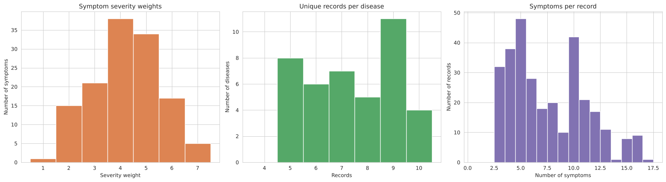
Figure 5.1: Symptom severity weights (left), unique records per disease after cleaning (middle) and symptoms per record (right).
Most symptoms have a severity of 3 – 5. After removing duplicates each disease has 5 – 10 records; this mild imbalance is handled with a stratified split and macro-averaged metrics instead of oversampling, which would only create new duplicates. Records contain between 3 and 17 symptoms.

5.1 Disease Class Balance
What class balance means. A classification dataset is balanced when every class (here, every disease) has roughly the same number of examples, and imbalanced when some classes have many more examples than others. Class balance matters because most learning algorithms minimise the overall error: when one class dominates, a model can reach a high accuracy by favouring that class while performing poorly on the rare ones, and plain accuracy then hides this failure. Common remedies for imbalance are oversampling the minority classes (e.g. SMOTE), undersampling the majority classes, class weighting (class_weight="balanced" in scikit-learn), stratified splitting, and reporting class-sensitive metrics such as macro-averaged precision, recall and F1-score.
Is it relevant to our project? Yes, it had to be checked: the task has 41 classes, and a disease with few records could be largely ignored by the model. In the raw file every disease has exactly 120 records, but after duplicate removal each disease has between 5 and 10 unique records (Figure 5.1, middle), so the cleaned data are mildly imbalanced.
Do we need to correct it? Only mildly, and without resampling. Oversampling (e.g. SMOTE) would create artificial copies of records — exactly the duplicates that were removed — so it was not used. Instead, the train/test split and every cross-validation fold are stratified (stratify=y and StratifiedKFold), so each disease keeps the same share in every subset, and all class-level metrics are macro-averaged, which gives every disease the same weight (Section 11).

6. Encoding
Because each patient reports a variable-length subset of the 131 possible symptoms, a simple LabelEncoder per column is not applicable. Instead, a two-stage encoding process was used.

6.1 Building a Symptom Set per Record
The 17 Symptom_1…Symptom_17 columns were collapsed, row by row, into one sorted tuple containing only the symptoms reported in that record (empty cells skipped). This is the same symptoms column used to remove duplicates in Section 4.3 (Step 5); after duplicate removal it holds the 304 unique symptom sets:
df["symptoms"] = df[symptom_cols].apply(lambda r: tuple(sorted(s for s in r if pd.notna(s))), axis=1)
For example, the first record’s symptom set is (dischromic_patches, itching, nodal_skin_eruptions, skin_rash).

6.2 Multi-hot Encoding of Symptoms (MultiLabelBinarizer)
mlb = MultiLabelBinarizer()
X = mlb.fit_transform(data["symptoms"]) # 304 × 131 binary matrix (1 = symptom present)
A MultiLabelBinarizer fitted on the full collection of per-patient symptom lists automatically discovers all 131 distinct symptoms in the data and converts each patient’s symptom list into a binary vector of length 131 (1 = symptom present, 0 = absent). The resulting dimensions are reported in Table 6.1.
Table 6.1: Encoding results.
Item | Value
Shape of feature matrix X | (304, 131) — 304 unique records × 131 symptoms
Number of symptoms identified by the encoder | 131

6.3 Label Encoding of the Target (Disease)
Unlike the symptoms, each patient has exactly one disease, so a standard LabelEncoder was used to convert the 41 disease names into integer class labels 0–40. The result is summarised in Table 6.2, and the full label-to-disease mapping is given in Table 3.3:
le = LabelEncoder()
y = le.fit_transform(data["Disease"]) # 41 disease labels -> 0 … 40
Table 6.2: Label encoding results.
Item | Value
Number of disease categories after encoding | 41
Example mapping | 0 ↔ (vertigo) Paroymsal Positional Vertigo

7. Train / Test Split (80% / 20%)
The encoded data was split into training and test sets using an 80% / 20% stratified split with a fixed random seed (random_state = 42):
X_train, X_test, y_train, y_test = train_test_split(X, y, test_size=0.20, stratify=y, random_state=SEED)
Stratification on the target ensures each of the 41 disease classes is represented in the same proportion in both sets. The resulting set sizes are given in Table 7.1.
Table 7.1: Train/test split results.
Set | Shape | Records per disease
Training set | (243, 131) | 4 – 8 records per disease (all 41 diseases)
Test set | (61, 131) | 1 – 2 records per disease (all 41 diseases)

The 304 unique records were split with a stratified 80/20 split (random_state = 42) into 243 training records and 61 test records; every disease appears in both sets. A check confirms that no test record is identical to any training record, so the two sets are completely separate.
However, because of the structure described in Section 4.3, each test record differs from a training record of the same disease by only one symptom (average Jaccard similarity 0.86). With all 131 symptoms the 41 diseases do not overlap at all, and any good model reaches 100% (cross-validated macro-F1 = 1.000 with 131 symptoms, Figure 8.2). This 100% reflects the dataset, not real diagnostic performance. The next step addresses it.

7.1 Why the Earlier 100% Accuracy Was Not Real: Data Leakage and Overfitting
An earlier version of the code kept all 4,920 rows and split them directly 80/20 (3,936 training and 984 test records), and the models reached about 100% accuracy. This result did not measure real diagnostic performance, for two related reasons.
Data leakage. Leakage happens when information from the test set is, directly or indirectly, available to the model during training, so the test score no longer reflects performance on new patients. Because 4,616 of the 4,920 rows are copies of the 304 unique records, a random split placed copies of the same record in both the training and the test set. The model was therefore tested mostly on records it had already seen during training.
Overfitting (memorisation). A model overfits when it learns the individual training records instead of general patterns: it performs very well on the training data but worse on new data. With duplicated records, a model that simply memorises every training record also scores 100% on the test set, so the overfitting is hidden.
What the final code does to prevent this:
- Duplicates are removed before splitting (Section 4.3), and the code checks that no test record is identical to a training record (0 found).
- Feature selection uses the training set only and is repeated inside every cross-validation fold through a Pipeline (Section 8), so the test set never influences which symptoms are used.
- Hyperparameters are chosen by cross-validation on the training set only (Section 9); the test set is used once, for the final evaluation.
- Regularisation limits overfitting: C in Logistic Regression and SVM, the L2 penalty alpha in the MLP, and the averaging of 500 trees in the Random Forest (Section 10).
- The whole procedure is repeated over 10 different random splits (Section 12.2) to check that the results do not depend on one favourable split.
Even after removing duplicates, using all 131 symptoms still gives 100%, because in this dataset every disease has some symptoms that no other disease has (Figure 8.2). This is a property of the dataset rather than real diagnostic skill, which is why the models use the 30 most informative symptoms (Section 8).

8. Feature Selection: The 30 Most Informative Symptoms
A practical symptom checker asks a patient a short list of questions rather than 131. The model was therefore restricted to the 30 symptoms with the highest Mutual Information (MI) with the disease. MI measures how much knowing whether a symptom is present reduces the uncertainty about the disease. It was computed on the training set only, and inside every cross-validation fold through a scikit-learn Pipeline (SelectKBest → classifier), so no information from the test set is used.

8.1 What Mutual Information Measures
Mutual Information is a filter-type feature-selection technique: it scores every feature on its own, before and independently of any classification model. For a symptom X (present = 1, absent = 0) and the disease label Y, MI measures how much knowing whether the symptom is present reduces the uncertainty about which disease the patient has:
$$I(X; Y) = Σx Σy p(x, y) · log [ p(x, y) / ( p(x) · p(y) ) ]$$
MI is zero when the symptom and the disease are independent, and it grows as the symptom becomes more informative about the disease. scikit-learn computes it in nats (natural logarithm). For a binary symptom the score cannot exceed the symptom’s own entropy, which is at most ln 2 ≈ 0.693 nats. MI suits this project because the features are binary, the target has 41 classes, and MI captures any kind of dependency, not only linear correlation.

8.2 Implementation
N_FEATURES = 30
mi_score = partial(mutual_info_classif, discrete_features=True, random_state=SEED)
mi = pd.Series(mi_score(X_train, y_train), index=symptom_names).sort_values(ascending=False)
selected = mi.head(N_FEATURES)

def make_pipe(clf): # used for every model
return Pipeline([("select", SelectKBest(mi_score, k=N_FEATURES)), ("clf", clf)])
discrete_features=True tells scikit-learn that every feature is 0/1, so MI is computed by exact counting. partial(...) fixes these arguments so that the same scoring function can be used inside SelectKBest. Because SelectKBest is the first step of the Pipeline, MI is recomputed on the training part of each cross-validation fold, and the validation part and the test set are never used to choose symptoms.
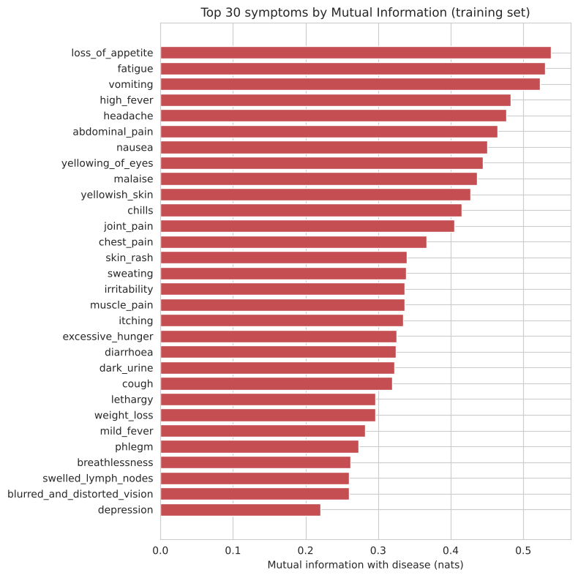
Figure 8.1: The 30 symptoms with the highest Mutual Information (training set).
The selected symptoms are general, frequently reported ones (loss of appetite, fatigue, vomiting, high fever, headache, …). Rare, disease-specific symptoms are left out, so some diseases now share the same visible symptoms, which makes the task realistic.

8.3 Choosing the Number of Symptoms
To choose how many symptoms to keep, the cross-validated macro-F1 of Logistic Regression was computed for k = 10, 20, 30, 40, 60, 90 and 131 symptoms (notebook Section 8.1; 3-fold stratified CV on the training set, Section 9):
for k in [10, 20, 30, 40, 60, 90, 131]:
pipe = Pipeline([("select", SelectKBest(mi_score, k=k)), ("clf", LogisticRegression(max_iter=5000))])
cross_val_score(pipe, X_train, y_train, cv=cv, scoring="f1_macro").mean()
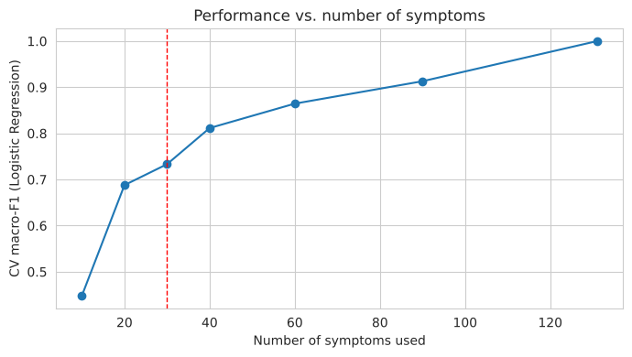
Figure 8.2: Cross-validated macro-F1 of Logistic Regression (training set) against the number of symptoms used. The red line marks the 30 symptoms used.
Performance increases with the number of symptoms and reaches 1.000 with all 131. 30 symptoms was chosen as a practical questionnaire size. Its cost is that some records contain none of the selected symptoms (23 training and 5 test records). N_FEATURES is a single variable in the notebook and can be changed.

9. Cross-Validation
What it is. Cross-validation (CV) estimates how well a model will perform on data it has not seen, using only the training set. In k-fold cross-validation the training set is divided into k equal parts (folds). The model is trained k times; each time one fold is held out for validation and the other k − 1 folds are used for training. The k validation scores are then averaged:
$$\text{CV score}=\frac{1}{k}\sum_{j=1}^{k}{{\text{macro-F1}}_{j}}$$
Why we used it. After duplicate removal the dataset is small (243 training records, 4–8 per disease). With a single validation split, the score would depend strongly on the few records that happen to fall into it, and settings chosen on it could fit that split by chance. Averaging over several folds gives a more reliable estimate, every training record is used for both training and validation, and the test set stays untouched until the final evaluation.
Which type we used. The most common choices are 5-fold and 10-fold CV. The our code uses 3-fold stratified CV:
cv = StratifiedKFold(n_splits=3, shuffle=True, random_state=SEED)
- Stratified: each fold keeps the proportion of every disease, so all 41 diseases appear in every fold.
- 3 folds instead of 5 or 10: the smallest disease has only 4 training records. With 5 or 10 folds, some validation folds would contain no record of that disease (scikit-learn warns when a class has fewer members than n_splits), and its F1-score could not be computed in those folds. With 3 folds every disease has at least one record in each validation fold.
- shuffle=True, random_state=42: the records are shuffled before the folds are formed, and the fixed seed makes the folds reproducible.
Where it is used in the code. (1) To choose the number of symptoms with cross_val_score (Section 8.3, Figure 8.2); (2) to tune the hyperparameters of the four models with GridSearchCV (Section 10, Table 10.1). In both cases the score is the macro-F1, and feature selection is repeated inside each fold through the Pipeline. Figure 9.1 illustrates the procedure.
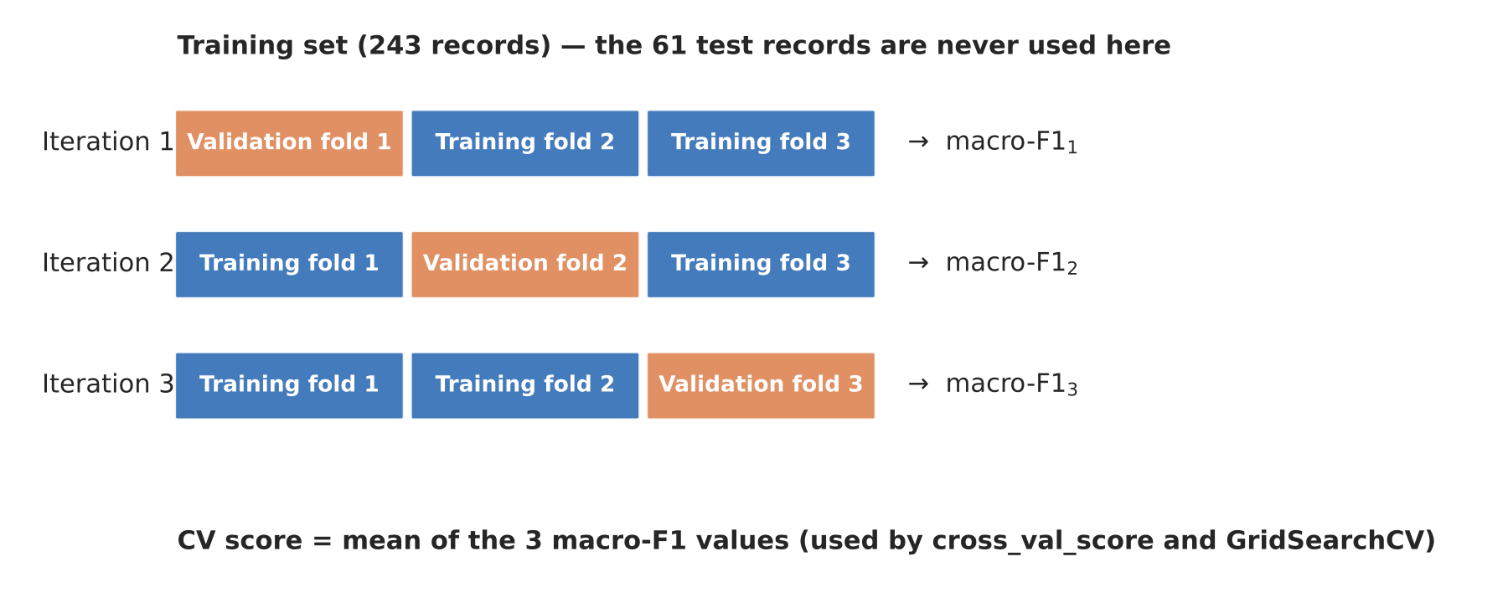
Figure 9.1: 3-fold stratified cross-validation on the training set, as implemented with StratifiedKFold(n_splits=3).
Cross-validation versus repeated splits. Section 12.2 repeats the whole 80/20 split with 10 different seeds. This is not k-fold CV but repeated hold-out validation: it measures how much the final test score changes from one split to another.

10. The Four Selected Classifiers
Four classifiers were compared, as agreed with the supervisor: Logistic Regression, Support Vector Machine, Random Forest and a Neural Network (MLP). They represent four different families of methods — a linear probabilistic model, a maximum-margin model, a tree ensemble and a neural network. Each model is a Pipeline (SelectKBest with 30 symptoms → classifier), and its hyperparameters were tuned with GridSearchCV (3-fold stratified cross-validation, macro-F1) on the training set only:
gs = GridSearchCV(make_pipe(clf), grid, cv=cv, scoring="f1_macro", n_jobs=-1).fit(X_train, y_train)
models[name] = gs.best_estimator_
GridSearchCV tries every combination of values in the grid, scores each with 3-fold CV, and finally refits the best combination on the whole training set. The search spaces and selected values are given in Table 10.1 at the end of this section.

10.1 Logistic Regression (LR)
How it works: multinomial (softmax) logistic regression learns one weight for each symptom and each disease. For a new patient, the weights of the symptoms present are summed for each disease and converted into 41 probabilities that add up to 1.
Mathematical formulation. For a patient with symptom vector x (30 values, 0 or 1), the model computes one score per disease k, a weighted sum of the symptoms that are present:
$$z_{k}=w_{k}^{⊤}x+b_{k}$$
The 41 scores are converted into probabilities that add up to 1 with the softmax function:
$$P\left(y=k∣x\right)=\frac{e^{z_{k}}}{\sum_{j=1}^{41}{e^{z_{j}}}}$$
The weights are learned by minimising the log-loss (cross-entropy) of the training records plus an L2 penalty that keeps the weights small. In scikit-learn C multiplies the data term, so a larger C means weaker regularisation:
$$\min_{W, b} \frac{1}{2}∥W∥^{2}-C\sum_{i=1}^{n}{log}P\left(y_{i}∣x_{i}\right)$$
The predicted disease is the one with the highest probability. For two classes the softmax reduces to the logistic (sigmoid) function σ(z) = 1 / (1 + e^(−z)) shown in Figure 10.1a, which gives the method its name.
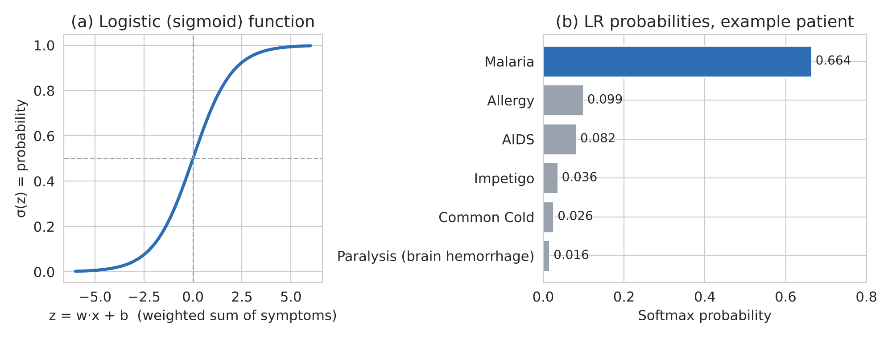
Figure 10.1: (a) The logistic function, which turns a weighted sum into a probability. (b) Probabilities given by the tuned Logistic Regression to an example patient with high fever, chills, sweating, headache and muscle pain (notebook Section 12).
Properties: a linear model with L2 regularisation controlled by C (the inverse of the regularisation strength). It produces probabilities, trains in a fraction of a second and predicts almost instantly. Its weights are directly interpretable: a large positive weight means a symptom strongly supports a disease. Its limitation is that it can only draw linear boundaries.
Selected setting: C = 10.

10.2 Support Vector Machine (SVM)
How it works: the SVM finds the boundary that separates diseases with the widest possible margin. For 41 classes it trains one classifier for each pair of diseases (one-vs-one) and combines their votes.
Mathematical formulation. For two classes, the SVM looks for a hyperplane f(x) = 0 that separates them, where
$$f\left(x\right)=w^{⊤}x+b$$
The distance between the hyperplane and the closest records on each side (the margin) is 2 / ‖w‖, so maximising the margin means minimising ‖w‖. Because classes usually overlap, slack variables ξᵢ allow some records inside the margin or on the wrong side, and C sets the penalty for these errors (soft margin):
$$\min_{w, b, ξ} \frac{1}{2}∥w∥^{2}+C\sum_{i=1}^{n}{ξ_{i}} \text{subject to} y_{i}\left(w^{⊤}x_{i}+b\right)≥1-ξ_{i}, ξ_{i}≥0$$
Only the records that lie on or inside the margin — the support vectors — determine the hyperplane (Figure 10.2a). When the classes cannot be separated by a flat hyperplane, the kernel trick replaces the dot product with a kernel function. The tuned model uses the RBF (Gaussian) kernel, which measures the similarity of two symptom vectors (γ is left at the scikit-learn default, gamma = 'scale'):
$$K\left(x,x'\right)=exp\left(-γ∥x-x'∥^{2}\right)$$
This lets the SVM draw curved boundaries in the symptom space (Figure 10.2b). For the 41 diseases, scikit-learn’s SVC trains one binary SVM for each pair of diseases (41 × 40 / 2 = 820 classifiers) and predicts by voting; probability=True adds a calibration step so that the model also outputs probabilities, which are needed for ROC-AUC.
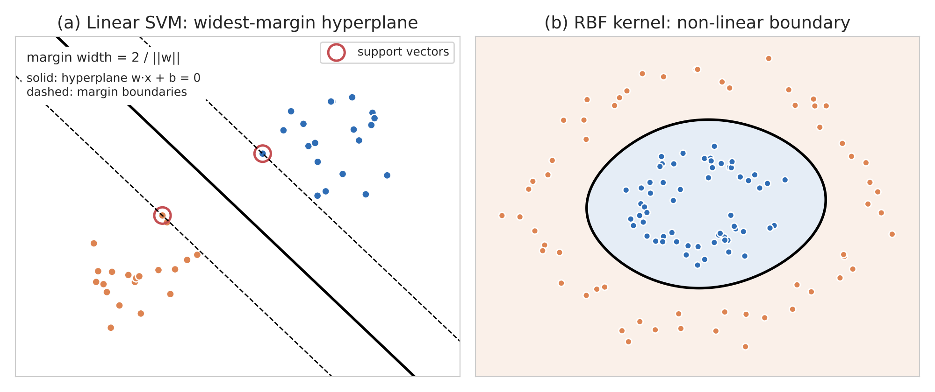
Figure 10.2: Illustration on synthetic two-dimensional data (not the project data): (a) linear SVM with its hyperplane, margin and support vectors; (b) the RBF kernel producing a non-linear boundary.
Properties: the margin makes it robust, and kernels allow non-linear boundaries. It works well with few records and many binary features. Its limitations are that probabilities must be estimated by an extra calibration step and that the RBF kernel is hard to interpret.
Selected setting: RBF kernel, C = 10.

10.3 Random Forest (RF)
How it works: an ensemble of decision trees. Each tree is trained on a bootstrap sample of the records and considers a random subset of symptoms at each split; the prediction is the majority vote of the trees.
Mathematical formulation. Each tree is grown by repeatedly splitting the records on the symptom that best separates the diseases. The quality of a split is measured with the Gini impurity of the resulting nodes, where p_k is the share of records of disease k in a node; a pure node (only one disease) has G = 0:
G=1-k​pk2
Two sources of randomness make the trees different from each other: each tree is trained on a bootstrap sample (records drawn with replacement from the 243 training records), and at each split only a random subset of the symptoms is considered — with max_features = log2 and 30 symptoms, 4 symptoms per split. In scikit-learn the final prediction averages the class probabilities of the T = 500 trees (soft voting) and chooses the disease with the highest average (Figure 10.3):
$$P\left(y=k∣x\right)=\frac{1}{T}\sum_{t=1}^{T}{P_{t}}\left(y=k∣x\right), \hat{y}=arg\max_{k}P\left(y=k∣x\right)$$
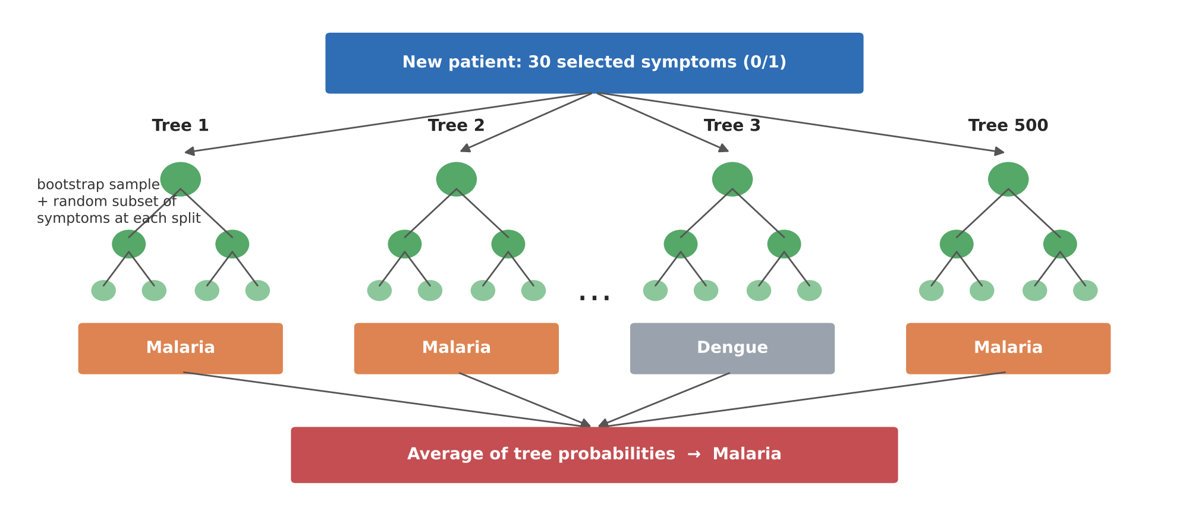
Figure 10.3: Schematic of the Random Forest: 500 trees, each trained on a bootstrap sample with random subsets of symptoms, combine their predictions by averaging probabilities (illustration).
Properties: averaging many trees reduces the overfitting of a single tree, no feature scaling is needed, and it provides feature importances. With only 4 – 8 training records per disease, each tree sees very few examples of each class, and it is the slowest to predict.
Selected setting: 500 trees, max_features = log2.

10.4 Neural Network (Multi-Layer Perceptron, MLP)
How it works: the symptom vector passes through a hidden layer of neurons with ReLU activation and then a softmax output layer over the 41 diseases. The weights are learned by back-propagation with the Adam optimiser.
Architecture. The tuned network has three layers (Figure 10.4): an input layer with the 30 selected symptoms, one hidden layer with 64 neurons, and an output layer with one neuron per disease (41). Every neuron is connected to all neurons of the next layer, giving 30 × 64 + 64 = 1,984 parameters in the first layer and 64 × 41 + 41 = 2,665 in the second — 4,649 trainable parameters in total.
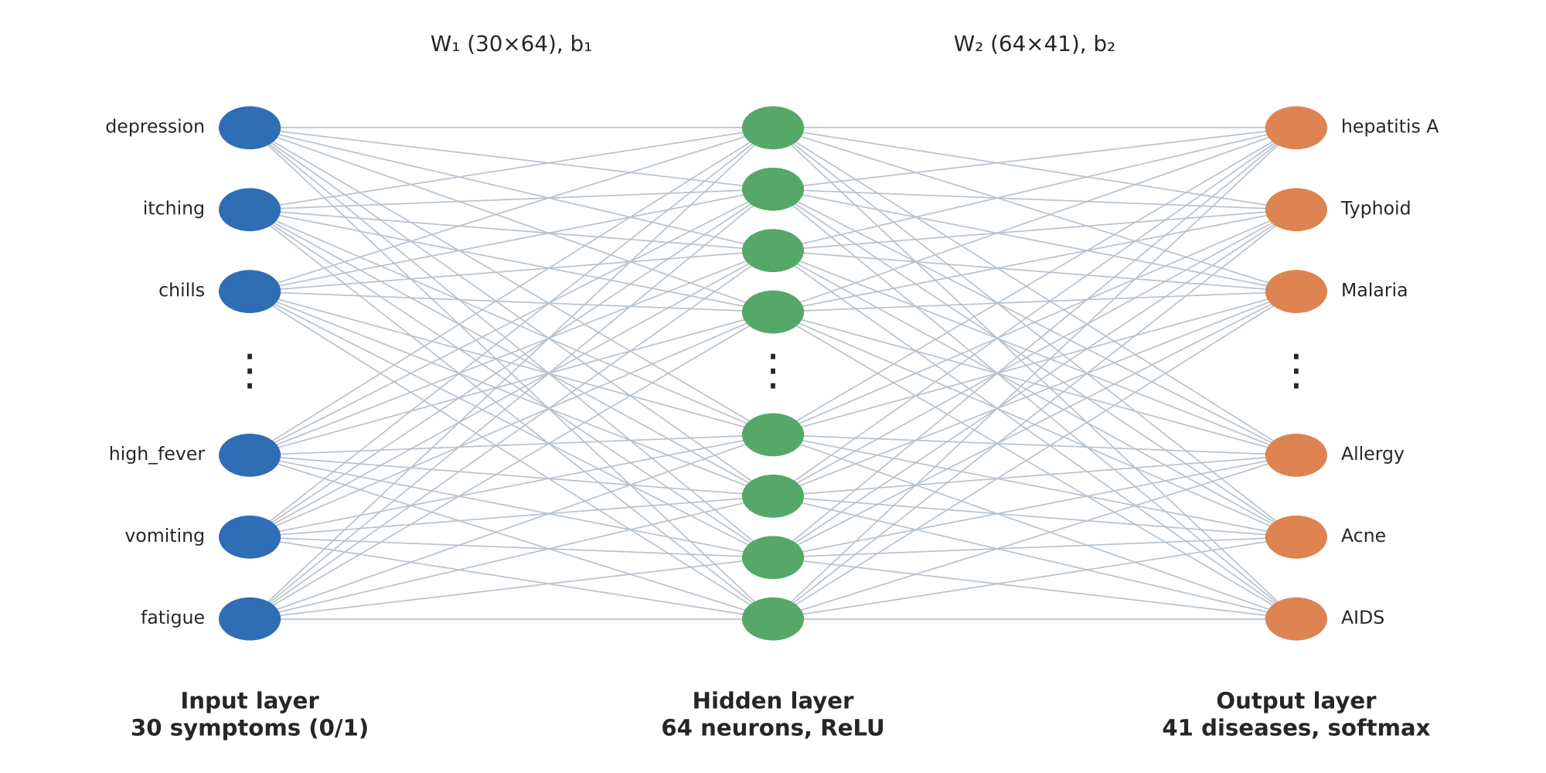
Figure 10.4: Architecture of the tuned MLP: 30 input symptoms → 64 hidden ReLU neurons → 41 softmax outputs (only some neurons are drawn).
Forward pass. Each hidden neuron computes a weighted sum of the symptoms and applies the ReLU activation, which keeps positive values and sets negative values to zero:
$$h=ReLU\left(W_{1}x+b_{1}\right), ReLU\left(z\right)=max\left(0,z\right)$$
The output layer computes a weighted sum of the 64 hidden values for each disease and applies softmax, exactly as in Logistic Regression:
$$P\left(y=k∣x\right)=softmax{\left(W_{2}h+b_{2}\right)}_{k}=\frac{e^{o_{k}}}{\sum_{j=1}^{41}{e^{o_{j}}}}, o=W_{2}h+b_{2}$$
An MLP without a hidden layer is therefore the same as multinomial Logistic Regression. The hidden layer is what allows the MLP to learn combinations of symptoms (for example, fever together with chills and sweating) that a linear model cannot represent.
Training. The weights start from small random values (random_state = 42) and are learned by back-propagation. For each mini-batch of training records the network makes a prediction, the error is measured with the cross-entropy loss plus an L2 penalty controlled by alpha, the gradient of this loss with respect to every weight is computed layer by layer from the output back to the input, and the Adam optimiser updates the weights. This is repeated until the loss stops improving or 2,000 epochs are reached (max_iter = 2000):
$$L=-\frac{1}{n}\sum_{i=1}^{n}{log}P\left(y_{i}∣x_{i}\right)+\frac{α}{2n}∥W∥^{2}$$
Why it performed best here. The 30 selected symptoms are general ones shared by several diseases, so a disease is often recognisable only from a combination of symptoms. The hidden layer can represent such combinations, while the small network (64 neurons) and the L2 penalty keep it from memorising the 243 training records. As a result, the MLP achieved the highest accuracy, macro-F1, MCC and Kappa on the test set and the highest mean accuracy and macro-F1 over the 10 repeated splits (Section 12).
Properties: it can learn combinations of symptoms that a linear model cannot. With only 243 training records it can overfit, its results depend on the random initial weights, and it is hard to interpret.
Selected setting: one hidden layer of 64 neurons, alpha (L2 penalty) = 0.0001.
Table 10.1: Hyperparameter search (training set only, 3-fold CV).
Model | Search space | Selected values | CV macro-F1
Logistic Regression | C ∈ {0.1, 1, 10, 100} | C = 10 | 0.7452
SVM | kernel ∈ {linear, rbf}; C ∈ {0.1, 1, 10} | rbf, C = 10 | 0.7408
Neural Network (MLP) | hidden layers ∈ {(64), (128, 64)}; alpha ∈ {0.0001, 0.01} | (64), alpha = 0.0001 | 0.7495
Random Forest | trees ∈ {200, 500}; max_features ∈ {sqrt, log2} | 500 trees, log2 | 0.7585

11. Evaluation Metrics
All class-level metrics were computed for each disease and averaged with equal weight (macro average). TP, TN, FP and FN are the true positives, true negatives, false positives and false negatives for one disease.
Table 11.1: Evaluation metrics.
Metric | Definition | What it tells us
Accuracy | (correct predictions) / (all predictions) | Overall share of patients assigned the correct disease.
Precision | TP / (TP + FP) | When the model predicts a disease, how often it is right.
Recall (Sensitivity) | TP / (TP + FN) | Of the patients who have a disease, how many the model finds.
Specificity | TN / (TN + FP) | Of the patients without a disease, how many are correctly ruled out.
F1-score | 2 × Precision × Recall / (Precision + Recall) | Balance between precision and recall.
MCC | Matthews correlation coefficient (−1 to 1) | Chance-corrected score using the whole confusion matrix.
Cohen's Kappa | Agreement corrected for chance (−1 to 1) | How much better the model is than random guessing.
ROC-AUC | Area under the ROC curve, one-vs-rest | How well the correct disease is ranked above the others.
Train / predict time | Seconds | Computational cost.

12. Results

12.1 Results on the 80/20 Test Set
Table 12.1: Performance on the test set (61 records; macro averages; Acc. = accuracy, Prec. = precision, AUC = ROC-AUC).
Model | Acc. | Prec. | Recall | Specif. | F1 | MCC | Kappa | AUC | Errors
Neural Network (MLP) | 0.9016 | 0.8138 | 0.8537 | 0.9976 | 0.8244 | 0.9019 | 0.8989 | 0.9941 | 6
Logistic Regression | 0.8852 | 0.8057 | 0.8415 | 0.9971 | 0.8114 | 0.8852 | 0.8820 | 0.9945 | 7
SVM | 0.8689 | 0.7610 | 0.8171 | 0.9967 | 0.7764 | 0.8683 | 0.8652 | 0.9896 | 8
Random Forest | 0.8525 | 0.7407 | 0.8049 | 0.9963 | 0.7593 | 0.8523 | 0.8483 | 0.9803 | 9

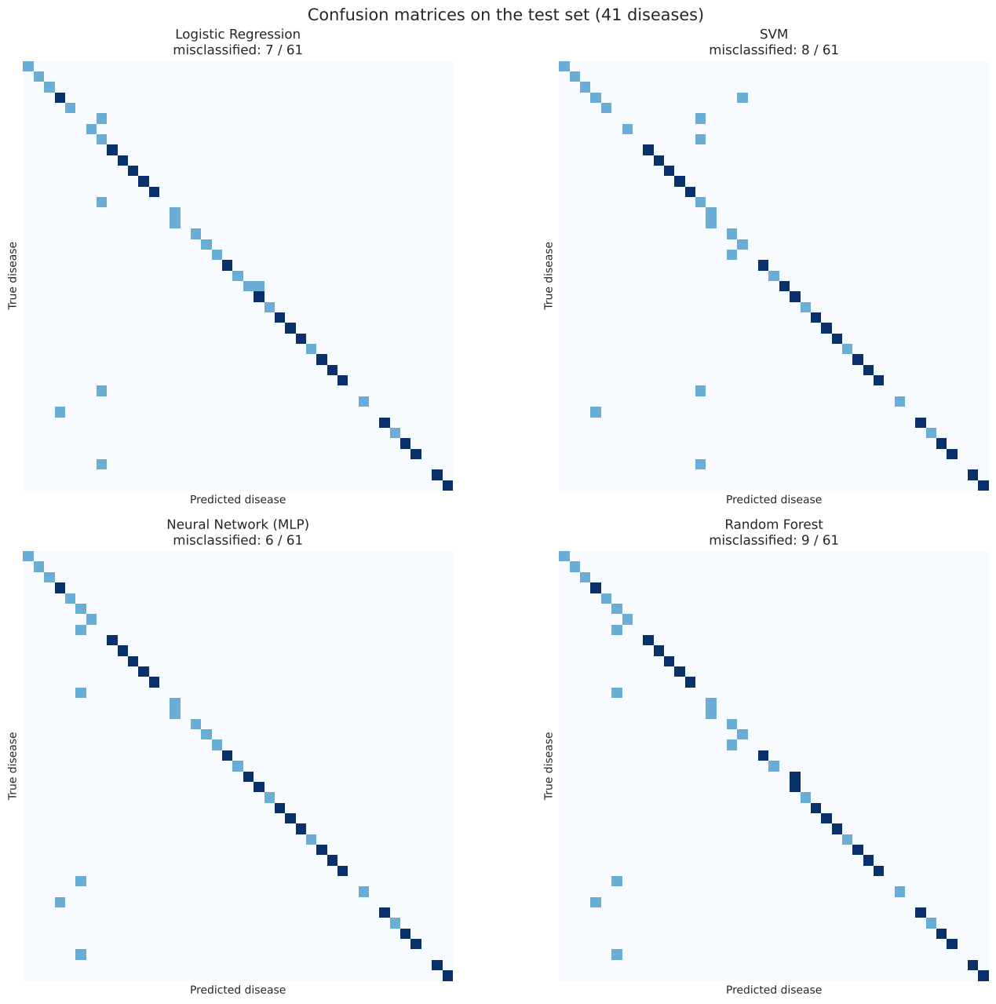
Figure 12.1: Confusion matrices on the test set. Correct predictions lie on the diagonal; off-diagonal cells are errors.
The MLP made the fewest errors (6 of 61, accuracy 0.9016), followed by Logistic Regression (7), SVM (8) and Random Forest (9). Macro F1 is lower than accuracy because each disease has only 1 – 2 test records, so a single error strongly lowers that disease's F1. The errors fall into three groups:
- Records with no selected symptom (4 errors per model): 5 test records (Arthritis, Cervical spondylosis, Osteoarthritis, Urinary tract infection and Dimorphic haemorrhoids) contain none of the 30 selected symptoms, so their input vector is all zeros. Every model predicts the same disease for all of them and can be right at most once. This is the direct cost of using a 30-symptom questionnaire.
- Diseases that share their visible symptoms: Fungal infection → Drug Reaction (only “itching” visible; all four models), Peptic ulcer disease → Alcoholic hepatitis (only abdominal pain and vomiting visible; all four models) and Hepatitis D → Hepatitis E (identical visible liver symptoms; LR and RF).
- Model-specific errors: Heart attack → GERD (SVM and RF; chest pain, breathlessness and vomiting are shared) and Alcoholic hepatitis → Gastroenteritis (SVM).

12.2 Stability over 10 Repeated 80/20 Splits
With 61 test records, one error changes accuracy by 1.6 percentage points. The full procedure (split → feature selection → training with the tuned settings → testing) was therefore repeated with 10 different random seeds.
Table 12.2: Mean ± standard deviation over 10 repeated 80/20 splits, and computational cost on the single 80/20 split.
Rank | Model | Accuracy | Macro F1 | Train time (s) | Predict time (s)
1 | Neural Network (MLP) | 0.8689 ± 0.0243 | 0.7754 ± 0.0356 | 1.36 | 0.001
2 | Logistic Regression | 0.8590 ± 0.0256 | 0.7655 ± 0.0357 | 0.31 | 0.001
3 | Random Forest | 0.8508 ± 0.0237 | 0.7564 ± 0.0340 | 1.17 | 0.140
4 | SVM | 0.8508 ± 0.0213 | 0.7453 ± 0.0338 | 0.26 | 0.003

The training and prediction times are those printed by the notebook for the single 80/20 split (notebook Section 10). They were measured in Google Colab and change slightly from one run to another; the earlier version of this table showed times from a different run.
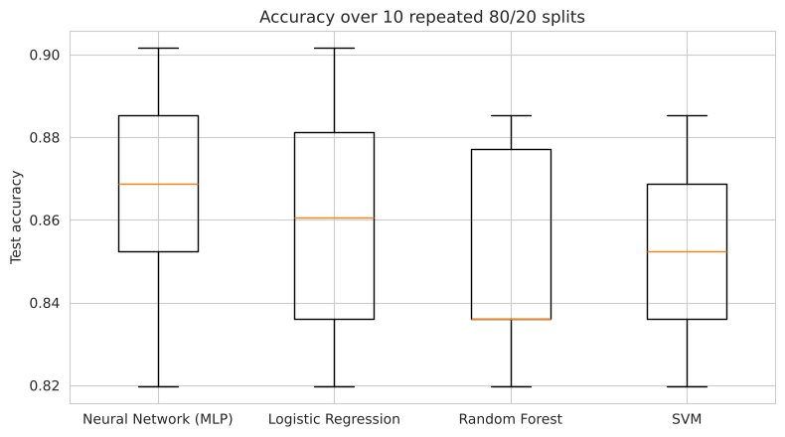
Figure 12.2: Test accuracy of each model over the 10 repeated 80/20 splits.
The ranking is the same as on the single split: MLP first, then Logistic Regression, with Random Forest and SVM slightly lower. The differences between models (about 1 – 2 points) are smaller than the standard deviations (about 2.5 points), so the four models perform similarly and the ranking is a tendency rather than a clear gap.

13. Discussion
We removed duplicate records; training and test records were separated with an 80/20 split; and the models use the 30 most informative symptoms instead of all 131. With all 131 symptoms the diseases in this dataset are perfectly separable, so 100% would be obtained even after removing duplicates; this is a property of the dataset and is reported for transparency (Figure 8.2).
Why is ROC-AUC much higher than accuracy? ROC-AUC measures whether the correct disease is ranked above the others, not whether it is ranked first. A model can rank the correct disease high (e.g. second) without choosing it, so ROC-AUC stays high while accuracy drops. Specificity is close to 1 because, with 41 diseases, almost every patient is correctly ruled out for the 40 diseases they do not have.
Limitations. The dataset is small after cleaning (304 records), so a 61-record test set gives wide uncertainty, which is why repeated splits are reported. The number of selected symptoms (30) is a design choice; more symptoms give higher scores (Figure 8.2). Records with none of the selected symptoms cannot be classified, which suggests always including at least one specific symptom per disease group in the questionnaire. The dataset is not from a clinical setting, so validation on real patient records would be needed before clinical use.

14. Selected Model
Two models stand out. The Neural Network (MLP) has the best scores on the test set (accuracy 0.9016, macro F1 0.8244) and over 10 repeated splits (0.8689 ± 0.0243). Logistic Regression is about one point lower (0.8590 ± 0.0256), within one standard deviation, but it trains four times faster and is fully interpretable.
The Neural Network (MLP) is selected as the final model. It achieved the best results on every main metric of the test set — accuracy 0.9016, macro-F1 0.8244, MCC 0.9019 and Kappa 0.8989, with the fewest errors (6 of 61) — and it also ranked first over the 10 repeated splits (accuracy 0.8689 ± 0.0243, macro-F1 0.7754 ± 0.0356). Its hidden layer lets it combine the general symptoms that remain after feature selection, which a linear model cannot do, and its prediction is as fast as that of Logistic Regression (about 0.001 s for the whole test set).
Logistic Regression is kept as the second-best and fully interpretable model. Because the differences between the models are within one standard deviation (Section 12.2), its weights are used to explain which symptoms drive the predictions (Table 14.2), while the MLP gives the final prediction. Table 14.1 summarises the comparison.
Table 14.1: Summary comparison of the four classifiers (ordered by test-set macro-F1).
Model | Family / main idea | Test accuracy | Test macro-F1 | Accuracy, 10 splits | Main strength / weakness
Neural Network (MLP) | Neural network; hidden layer learns symptom combinations | 0.9016 | 0.8244 | 0.8689 ± 0.0243 | Best results / harder to interpret
Logistic Regression | Linear; weighted sum of symptoms + softmax | 0.8852 | 0.8114 | 0.8590 ± 0.0256 | Interpretable, fast / linear boundaries only
SVM | Maximum margin; RBF kernel | 0.8689 | 0.7764 | 0.8508 ± 0.0213 | Robust margin / hard to interpret
Random Forest | Ensemble of 500 randomised trees | 0.8525 | 0.7593 | 0.8508 ± 0.0237 | Feature importances / slowest prediction

Table 14.2: Symptoms with the largest Logistic Regression weights for selected diseases (among the 30 selected symptoms).
Disease | Top symptoms (weight)
Diabetes | lethargy (2.63), blurred_and_distorted_vision (1.87), weight_loss (1.86), excessive_hunger (1.74)
Malaria | muscle_pain (2.28), diarrhoea (1.77), chills (1.50), sweating (1.45)
Hypothyroidism | depression (2.68), irritability (2.39), fatigue (1.87), lethargy (1.37)

For example, a new patient reporting high fever, chills, sweating, headache and muscle pain receives Malaria (0.94), Allergy (0.04) and Dengue (0.005) as the three most likely diseases from the selected MLP; Logistic Regression ranks the same top disease, Malaria (0.66), followed by Allergy (0.10) and AIDS (0.08) (Figure 10.1b). The system can then show the description and precautions of the predicted disease from the other two data files.

15. Summary
- The data were cleaned and 4,616 duplicate records were removed, leaving 304 unique records.
- Training and test records were separated with a stratified 80/20 split (243 / 61) with no overlap.
- The 30 most informative symptoms (Mutual Information, training set only) were used as features.
- Four classifiers were tuned and compared. On the test set: MLP 0.9016, Logistic Regression 0.8852, SVM 0.8689, Random Forest 0.8525 accuracy. Over 10 repeated splits: MLP 0.8689, LR 0.8590, RF 0.8508, SVM 0.8508.
- Missing values: empty symptom cells mean “symptom not reported”, so they were skipped and no imputation was needed.
- Cross-validation: 3-fold stratified cross-validation on the training set was used to choose the number of symptoms and to tune the hyperparameters.
- The Neural Network (MLP) was selected as the final model because it achieved the best results; Logistic Regression is kept as an interpretable alternative that explains the predictions.

